Educational excursion
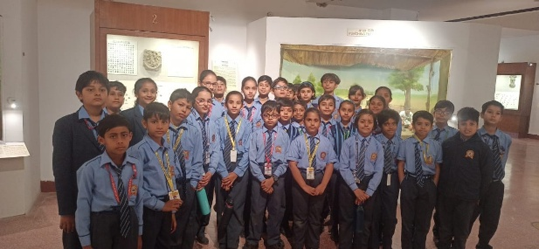
Ganga International School, Sawda organized an educational excursion for its students. The students of classes I to VIII visited Amrit Udyan, Rastrapati Bhawan, National War Memorial, India Gate and National Museum on 19th March 2024. The Amrit Udayan is called the ‘soul’ of the Presidential Palace and is open to the public every spring. Located in the heart of New Delhi inside Rashtrapati Bhawan, the gardens are a burst of vivid blooms and a visual treat. The picturesque landscape full of manicured lawns gave a chance to gain knowledge about various varieties of plants. The students got to know about various historic evens as they walked in the gallery of National War Museum. The students of elementary classes visited National Museum, they all were full of curiosity. The excursion was of outmost academic importance to the students. At the end of the visit the students were taken to the Children’s Park to play the tiredness away!!
